**This project consists of building data dashboards for visual representation using Tableau. The corresponding datasets document a variety of airline information including delays, cancellations, dates, and destinations. The dataset is from 2015 for major airlines and airport.**

**The goal of the dashboards are to visualize which airlines have the most delays and potential causes. This information could potentially be useful in the improvement and optimization of airlines, which could improve their branding, customer experience/satisfaction.**

**1. Insight no.1**

D1 = W0 + W1

* Links :

Tableau:

<https://public.tableau.com/authoring/Flights_16466427394090/Dashboard1/D1#1>

* Summary **:**

This visualization shows a comparison of airlines with delays, given in thousands of minutes. This shows that Southwest Airlines (WN) has the most delays of any kind, nearly double of any competitor and This visualization shows the occurrences of cancellations due to reasons (A, B, C) relative to the day given the week, time of month, and year. It can be seen that the primary cause of cancellations is "B" which accounts for more than half. While the Excel Sheet does not explicitly state what reason "B" is, looking at the month of February implies it is related to weather conditions since this is the dead of winter.

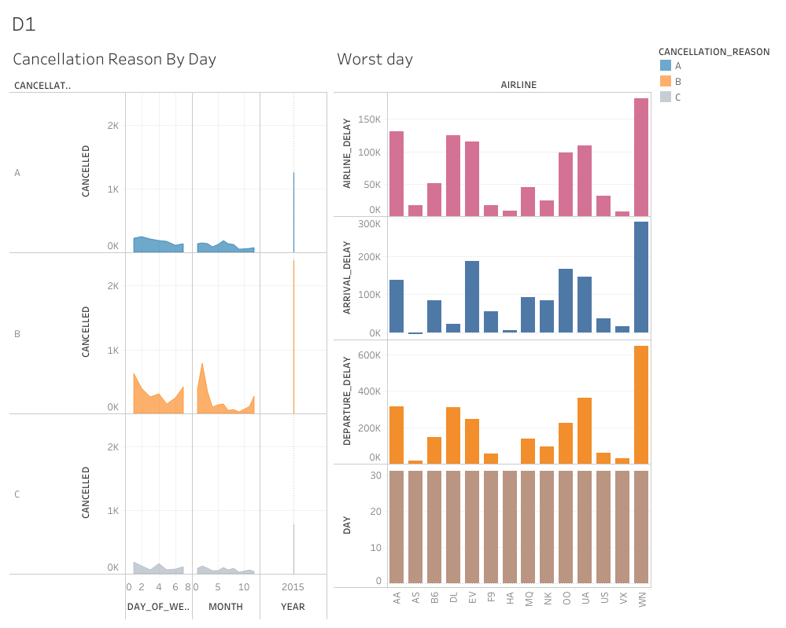

* Design  **:**

A Bar Chart is used to show data with minimal chart junk. A general negative slope can be seen as a trend.

* Resources :

Github , youtube , Udacity

**2. Insight no.2**

* Links :

Tableau

<https://public.tableau.com/authoring/Flights_16466427394090/Dashboard1/W2#1>

* Summary **:** While this graph still shows that Southwest (WN) still has the worst delays and cancellations, we can see that these issues are proportional to the total distance of the trip and the length of the flight time. This is relatively true for all airlines as well, except for American Eagle (MQ) that has a high amount of cancellations with respect to their flight times and distances.

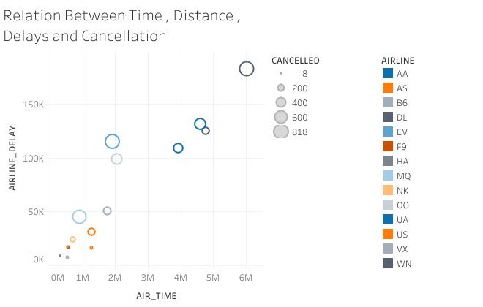

* Design **:**

A Bar Chart is used to show data with minimal chart junk. A general negative slope can be seen as a trend.

* Resources :

Github , youtube , Udacity

**3. Insight no.3**

* Links :

Tableau

<https://public.tableau.com/authoring/Flights_16466427394090/Dashboard1/W3#1>

* Summary **:**

After trying different reasons, it was found that the delay due to the air system has the greatest effect on the delay in departure. Also, the first day of the week had the highest rate of delay in leaving due to the air system I used the two-sided bar chart because it is most appropriate to make a quick comparison of the two variables, the delay in departure and the delay due to the air system for each day of the week, and distinguishing each variable with a color to facilitate comparison, taking into account that these colors are suitable for color-blind patients

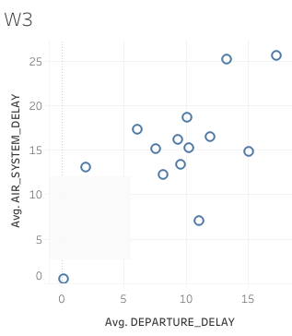

•Design :

I used the scatterplot with the two variables, the delay in departure and the delay due to the air system, because it is the most appropriate in knowing the extent of the relationship or correlation between two quantitative variables.

•Resources :

Github , youtube , Udacity